**MULTITHREADING**

**THREAD CREATION AND JOINING**

**CODE**

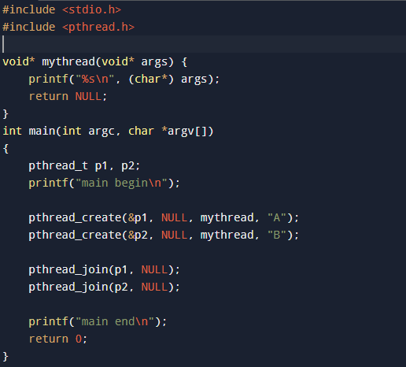

**OUTPUT**

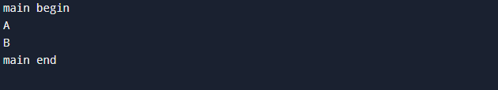

**SUM OF NUMBERS FROM 1 TO 100 USING MULTITHREADING**

**CODE**

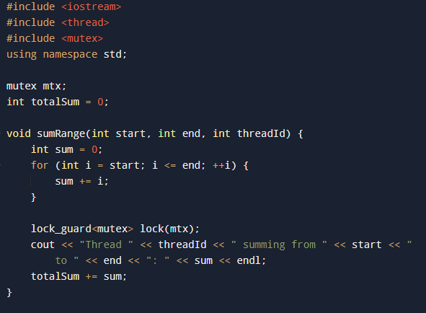

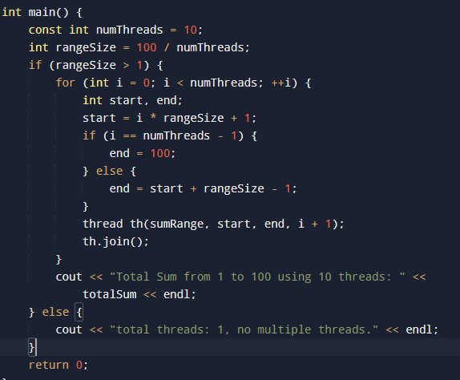

**OUTPUT**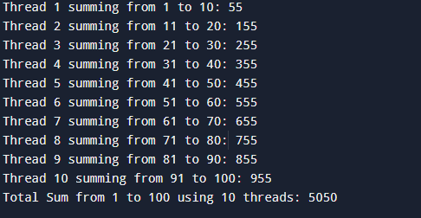

**OPENMP**

**PTHREADS VS OPENMP PERFORMANCE**

**CODE**

#include <pthread.h>

#include <sched.h>

#include <stdio.h>

#include <stdlib.h>

#include <unistd.h>

#include <omp.h>

#include <time.h>

#define NUM_THREADS 4

#define N 100000000 *// Size of the array*

*// Global array*

int array[N];

*// Mutex for thread synchronization*

pthread_mutex_t mutex_sum = PTHREAD_MUTEX_INITIALIZER;

long long sum_pthread = 0;

*// Function to set CPU affinity to core 0 (same core for all threads)*

void set_cpu_affinity_same_core() {

    cpu_set_t cpuset;

    CPU_ZERO(&cpuset); *// Initialize cpuset to be empty*

    CPU_SET(0, &cpuset); *// Assign thread to core 0*

    pthread_t current_thread = pthread_self();

    if (pthread_setaffinity_np(current_thread, sizeof(cpu_set_t), &cpuset) != 0) {

        perror("pthread_setaffinity_np");

        exit(EXIT_FAILURE);

    }

    printf("Thread %lu is now running on core 0\n", current_thread);

}

*// Function to set CPU affinity to different cores (0, 1, 2, ...)*

void set_cpu_affinity(int *core_id*) {

    cpu_set_t cpuset;

    CPU_ZERO(&cpuset);

    CPU_SET(*core_id*, &cpuset);

    pthread_t current_thread = pthread_self();

    if (pthread_setaffinity_np(current_thread, sizeof(cpu_set_t), &cpuset) != 0) {

        perror("pthread_setaffinity_np");

        exit(EXIT_FAILURE);

    }

    printf("Thread %lu is now running on core %d\n", current_thread, *core_id*);

}

*// Function to simulate work (sum array values)*

void* sum_pthread_func(void* *arg*) {

    int thread_id = *((int*)*arg*);

*// Bind threads to cores (for same-core or different cores)*

    if (thread_id < NUM_THREADS) {

        set_cpu_affinity(thread_id); *// Bind thread to different cores (option 2)*

    } else {

        set_cpu_affinity_same_core(); *// Bind all threads to core 0 (option 1)*

    }

    long long local_sum = 0;

    for (int i = thread_id * (N / NUM_THREADS); i < (thread_id + 1) * (N / NUM_THREADS); i++) {

        local_sum += array[i];

    }

*// Locking shared sum*

    pthread_mutex_lock(&mutex_sum);

    sum_pthread += local_sum;

    pthread_mutex_unlock(&mutex_sum);

    return NULL;

}

*// Function to initialize the array with random values*

void init_array() {

    for (int i = 0; i < N; i++) {

        array[i] = rand() % 1000;

    }

}

int main() {

    init_array();

*// Time comparison*

    struct timespec start, end;

*// Option 1: Pthreads on Same Core*

    printf("\n=== Pthreads on Same Core ===\n");

    clock_gettime(CLOCK_REALTIME, &start);

    pthread_t threads_same_core[NUM_THREADS];

    int thread_ids_same_core[NUM_THREADS] = {0, 0, 0, 0};

*// Create threads and bind all to core 0*

    for (int i = 0; i < NUM_THREADS; i++) {

        if (pthread_create(&threads_same_core[i], NULL, sum_pthread_func, (void*)&thread_ids_same_core[i]) != 0) {

            perror("pthread_create");

            exit(EXIT_FAILURE);

        }

    }

    for (int i = 0; i < NUM_THREADS; i++) {

        pthread_join(threads_same_core[i], NULL);

    }

    clock_gettime(CLOCK_REALTIME, &end);

    printf("Pthread sum (same core): %lld\n", sum_pthread);

    printf("Pthread (same core) execution time: %lf seconds\n",

           (end.tv_sec - start.tv_sec) + (end.tv_nsec - start.tv_nsec) / 1e9);

*// Reset the sum for the next experiment*

    sum_pthread = 0;

*// Option 2: Pthreads on Different Cores*

    printf("\n=== Pthreads on Different Cores ===\n");

    clock_gettime(CLOCK_REALTIME, &start);

    pthread_t threads_different_cores[NUM_THREADS];

    int thread_ids_different_cores[NUM_THREADS] = {0, 1, 2, 3};

*// Create threads and assign them to different cores*

    for (int i = 0; i < NUM_THREADS; i++) {

        if (pthread_create(&threads_different_cores[i], NULL, sum_pthread_func, (void*)&thread_ids_different_cores[i]) != 0) {

            perror("pthread_create");

            exit(EXIT_FAILURE);

        }

    }

    for (int i = 0; i < NUM_THREADS; i++) {

        pthread_join(threads_different_cores[i], NULL);

    }

    clock_gettime(CLOCK_REALTIME, &end);

    printf("Pthread sum (different cores): %lld\n", sum_pthread);

    printf("Pthread (different cores) execution time: %lf seconds\n",

           (end.tv_sec - start.tv_sec) + (end.tv_nsec - start.tv_nsec) / 1e9);

*// Reset the sum for the next experiment*

    sum_pthread = 0;

*// Option 3: OpenMP Parallel Execution*

    printf("\n=== OpenMP Parallel Execution ===\n");

    clock_gettime(CLOCK_REALTIME, &start);

    long long sum_openmp = 0;

*// Parallelize the summing of the array using OpenMP*

    #pragma omp parallel for reduction(+:sum_openmp)

    for (int i = 0; i < N; i++) {

        sum_openmp += array[i];

    }

    clock_gettime(CLOCK_REALTIME, &end);

    printf("OpenMP sum: %lld\n", sum_openmp);

    printf("OpenMP execution time: %lf seconds\n",

           (end.tv_sec - start.tv_sec) + (end.tv_nsec - start.tv_nsec) / 1e9);

    return 0;

}

**OUTPUT**

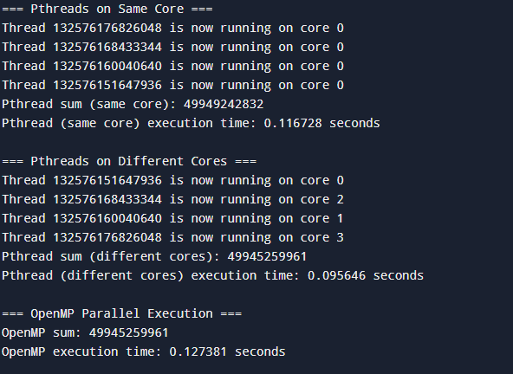

**SUMMATION USING OPENMP**

**CODE:**

#include <iostream>

#include <vector>

#include <cstdlib>

#include <ctime>

#include <omp.h>

int main() {

    int n = 1000000; *// Example array size*

    std::vector<int> arr(n);

    int sum = 0; *// Shared sum variable*

*// Initialize the array with random values between 1 and 100*

    srand(time(0));

    for (int i = 0; i < n; i++) {

        arr[i] = rand() % 100 + 1;

    }

*// Serial sum for baseline comparison*

    double start_time = omp_get_wtime();

    int serial_sum = 0;

    for (int i = 0; i < n; ++i) {

        serial_sum += arr[i];

    }

    double end_time = omp_get_wtime();

    std::cout << "Serial Sum: " << serial_sum << std::endl;

    std::cout << "Serial Execution Time: " << end_time - start_time << " seconds." << std::endl;

*// Parallel sum with reduction*

    start_time = omp_get_wtime();

    sum = 0;

    #pragma omp parallel for reduction(+:sum)

    for (int i = 0; i < n; ++i) {

        sum += arr[i];

    }

    end_time = omp_get_wtime();

    std::cout << "Parallel Sum with Reduction: " << sum << std::endl;

    std::cout << "Parallel Execution Time (Reduction): " << end_time - start_time << " seconds." << std::endl;

*// Parallel sum with atomic*

    start_time = omp_get_wtime();

    sum = 0;

    #pragma omp parallel for

    for (int i = 0; i < n; ++i) {

        #pragma omp atomic

        sum += arr[i];

    }

    end_time = omp_get_wtime();

    std::cout << "Parallel Sum with Atomic: " << sum << std::endl;

    std::cout << "Parallel Execution Time (Atomic): " << end_time - start_time << " seconds." << std::endl;

*// Parallel sum with critical section*

    start_time = omp_get_wtime();

    sum = 0;

    #pragma omp parallel for

    for (int i = 0; i < n; ++i) {

        #pragma omp critical

        sum += arr[i]; *// Only one thread at a time can update 'sum'*

    }

    end_time = omp_get_wtime();

    std::cout << "Parallel Sum with Critical: " << sum << std::endl;

    std::cout << "Parallel Execution Time (Critical): " << end_time - start_time << " seconds." << std::endl;

*// Parallel sum with locks*

    start_time = omp_get_wtime();

    sum = 0;

    omp_lock_t lock;

    omp_init_lock(&lock);

    #pragma omp parallel for

    for (int i = 0; i < n; ++i) {

        omp_set_lock(&lock);

        sum += arr[i];

        omp_unset_lock(&lock);

    }

    omp_destroy_lock(&lock);

    end_time = omp_get_wtime();

    std::cout << "Parallel Sum with Locks: " << sum << std::endl;

    std::cout << "Parallel Execution Time (Locks): " << end_time - start_time << " seconds." << std::endl;

*// Parallel sum without synchronization (Data Race)*

    start_time = omp_get_wtime();

    sum = 0;

    #pragma omp parallel for

    for (int i = 0; i < n; ++i) {

        sum += arr[i]; *// No synchronization, potential data race*

    }

    end_time = omp_get_wtime();

    std::cout << "Parallel Sum without Synchronization (Data Race): " << sum << std::endl;

    std::cout << "Parallel Execution Time (No Sync): " << end_time - start_time << " seconds." << std::endl;

    return 0;

}

**OUTPUT:**

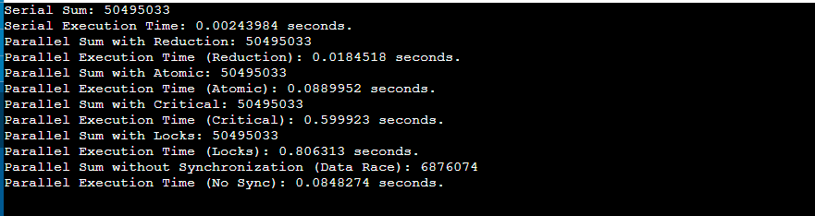

**COMPARISON TABLE**

| **Synchronization Method** | **Sum Correct?** | **Execution Time (s)** | **Remarks** |
| --- | --- | --- | --- |
| Serial Execution | Yes | 0.00243984 | Baseline for comparison |
| Parallel Sum with Reduction | Yes | 0.0184518 | Fast, minimal overhead |
| Parallel Sum with Atomic | Yes | 0.0889952 | Moderate overhead |
| Parallel Sum with Critical | Yes | 0.599523 | High overhead |
| Parallel Sum with Locks | Yes | 0.806313 | Highest overhead |
| No Synchronization (Data Race) | **No** | 0.0848274 | Fast but incorrect result (Data Race) |

**ADVANTAGES AND DRAWBACKS FOR EACH SYNCHRONIZATION METHOD:**

**REDUCTION:**

Advantage: Fast and efficient for aggregations.

Drawback: Limited to specific operations (e.g., sum, max).

**ATOMIC:**

Advantage: Avoids full locks with minimal overhead.

Drawback: Only suitable for simple, single-variable updates.

**CRITICAL:**

Advantage: Easy to use for protecting critical sections.

Drawback: Slows execution as only one thread can enter at a time.

**LOCKS:**

Advantage: Flexible and can protect multiple variables or complex logic.

Drawback: High overhead and potential for deadlocks.

**NO SYNCHRONIZATION:**

Advantage: Fastest execution without any coordination overhead.

Drawback: Unsafe due to race conditions, leading to incorrect results.

**SUM OF N NUMBERS USING OPEN MP**

**CODE**

#include <iostream>

#include <omp.h>

using namespace std;

int main() {

    int N = 100;

    int sum = 0;

*// Parallel loop with atomic to prevent race conditions*

    #pragma omp parallel for shared(sum)

    for (int i = 1; i <= N; i++) {

        #pragma omp atomic

        sum += i;

    }

    cout << "Final sum = " << sum << endl;

    return 0;

}

**OUTPUT**



**PRAM ALGORITHMS**

**MULTIPLE ACCESSES ON EREW**

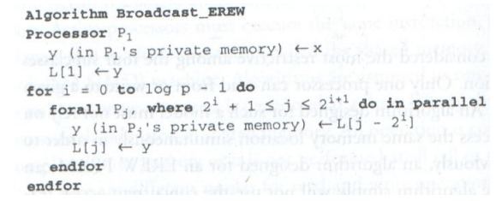

**COMPUTING SUM OF AN ARRAY ON EREW PRAM**

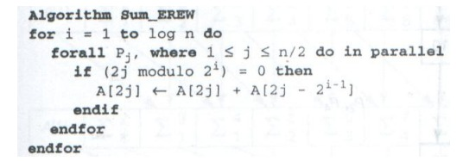**COMPUTING ALL PARTIAL SUM**

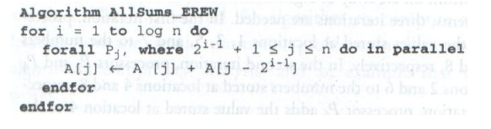**MATRIX MULTIPLICATION (CREW PRAM)**

